Pentecostal Assemblies of the World Ninth Episcopal Diocese of Alabama
ATM Prayer Line
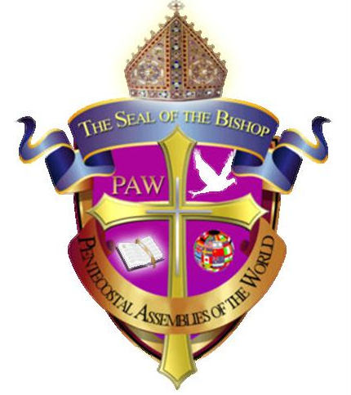
GUIDELINES UPDATED – SYSTEM MONITORS

The System Monitor will manage and mute any and all sounds, background noises, and distractions causing problems during
his/her assigned or authorized Prayer Watch. No monitor should be muting and unmuting the system without assignment and authorization.
All Hosts and System Monitors are requested to use these Keywords say that we all will be saying the same thing and helping to eliminate any possible miscommunication. Please disregard and discontinue the use of any other keywords.

Keywords for the System Monitor of each
watch will be as highlighted in bold print below:
- The host will announce the name of the scripture reader
who will read one verse of scripture, the name of the prayer & worship leader who will lead the prayer for 10-15 minutes and who will also lead the corporate worship for 2-3 minutes and the name of the Inspirational Speaker who will speak positive words of inspiration for 3-5 minutes. After which the host will say, please mute the lines and the line will then be muted.
- At the closing of Prayer and Corporate Worship
when the leader says - In the Name of Jesus. Amen the line will then be unmuted.
- Benediction/closing of the Prayer –When the Diocesan or Host say In the Name of Jesus, you are dismissed, the line then will be muted.
- The Host, and Diocesan, should remain unmuted unless their phones are causing problems.
Bishop G. F. Austin,
Diocesan

